Deputy for research

international campus

Registration Thesis in The Research System (Pajoheshyar)

Deputy for Research

International Campus

2023[Document subtitle]

**Registration in the Research System (Pajoheshyar):**

1. First, go to the website of Iran University of Medical Sciences' Pajoheshyar research system at <https://research.iums.ac.ir/>.
2. On the homepage of the website, in the Research Projects System section, select "Login in Pajoheshyar System."

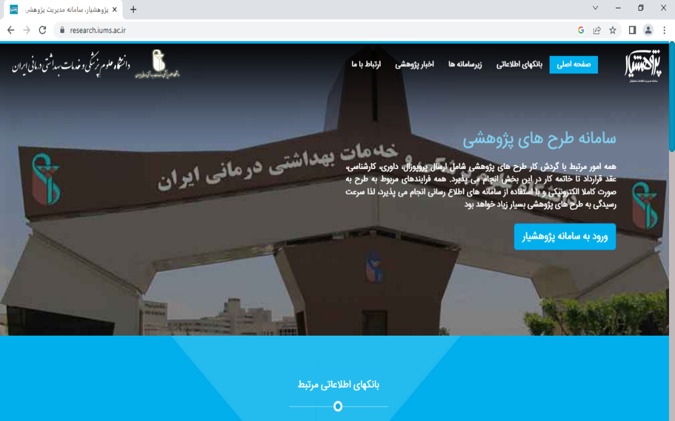

1. 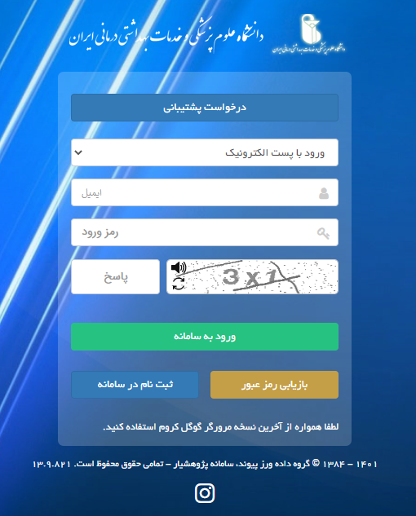In the next step, click on the "Register in the System" option to access the registration form.
2. Complete the required fields in the "Create a User Account" section. Note that the fields marked with an asterisk (*) are mandatory and must be filled out.
3. In the "Workplace or Education" section, after opening the dropdown menu for "+ Iran University of Medical Sciences," medical students should select "International Pardis," while students from other disciplines should select their respective faculties.

Finally, after completing the necessary sections, select the "Create User Account" option. If the registration is successful, your username and password will be sent to you via email and the provided contact number during registration.

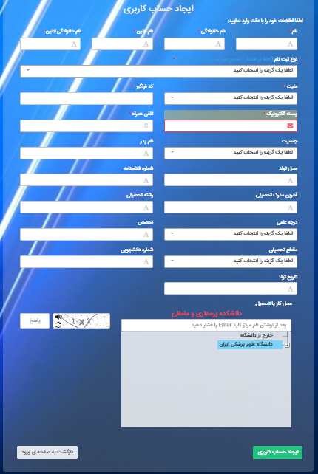

**Login to the Research System (Pajoheshyar):**

* After creating an account, go back to the Pajoheshyar website (<https://research.iums.ac.ir/>) and select "Login to Pajoheshyar System." Enter your account information (username and password) and then select the "Login to the System" option. Upon logging in, your name will appear as a user in the top left corner of the page.

**Profile Modification:**

* To change or edit your profile, hover the mouse pointer next to your username. A dropdown menu will appear, and by selecting the first option, "User Profile," you can access the options to modify your details.
* It is important to note that in order to change your profile, all requested information (both fields marked with an asterisk (*) and those without an asterisk) must be completed

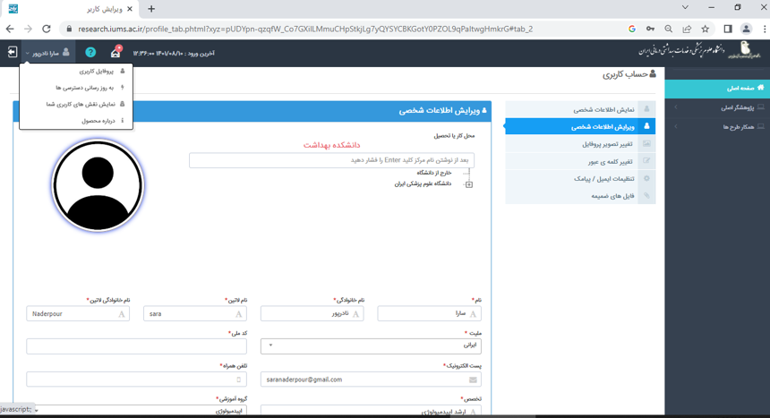

**Home Page Features of the Pajoheshyar Environment:**

* The home page of the Pajoheshyar environment consists of three sections: Quick Access, Search, Information, and Events.
* Quick Access: In this section, researchers can quickly access the sections based on the status of their registered research projects/theses.
* Search: In the search section, by entering any information related to a registered project/thesis (tracking code, title, etc.), the relevant project can be found.
* Information: In this section, researchers can access the latest guidelines, grants, research council meeting schedules, and more.
* Events: Messages and communications with project experts can be viewed and accessed in this section.

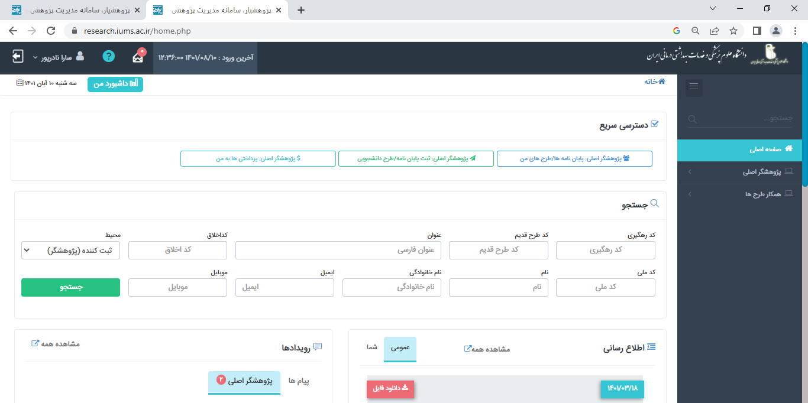

**Entering the information of a thesis proposal in the Researcher System**

After logging into the Researcher System, on the right side of the website, open the dropdown menu related to the main researcher and select "Register Thesis/Student Proposal."

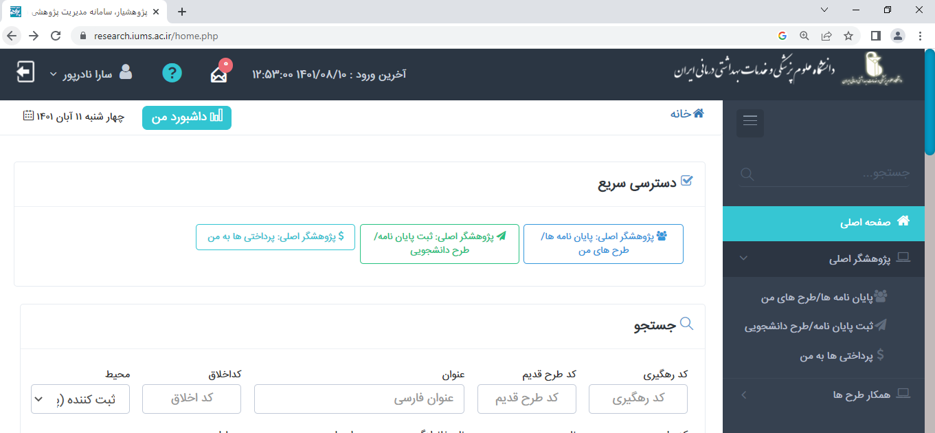

Then, in the thesis section, select "Start Registration" to enter the proposal/thesis registration stage.

**Characteristics of the Dissertation/Thesis:**

* After selecting "Start Registration," the following page opens for entering proposal information. In the first step, in the "Main Reviewer Center/Faculty" section, medical students should select "International Pardis," while students from other disciplines should select their respective faculties. It should be noted that if the desired thesis or project requires a second center, select the desired location in the "Secondary Target Center" section.
* Then, on the "Characteristics of the Dissertation/Thesis" page, complete all relevant information (main reviewer center/faculty, animal study status, project title in Persian and English, type of project, thesis level, study type, date of approval of the thesis title in the Graduate Studies Council and secretariat) based on the information approved in the proposal.
* Note: In the secretariat section, medical students should select "International Pardis," while students from other disciplines should select their respective faculty.

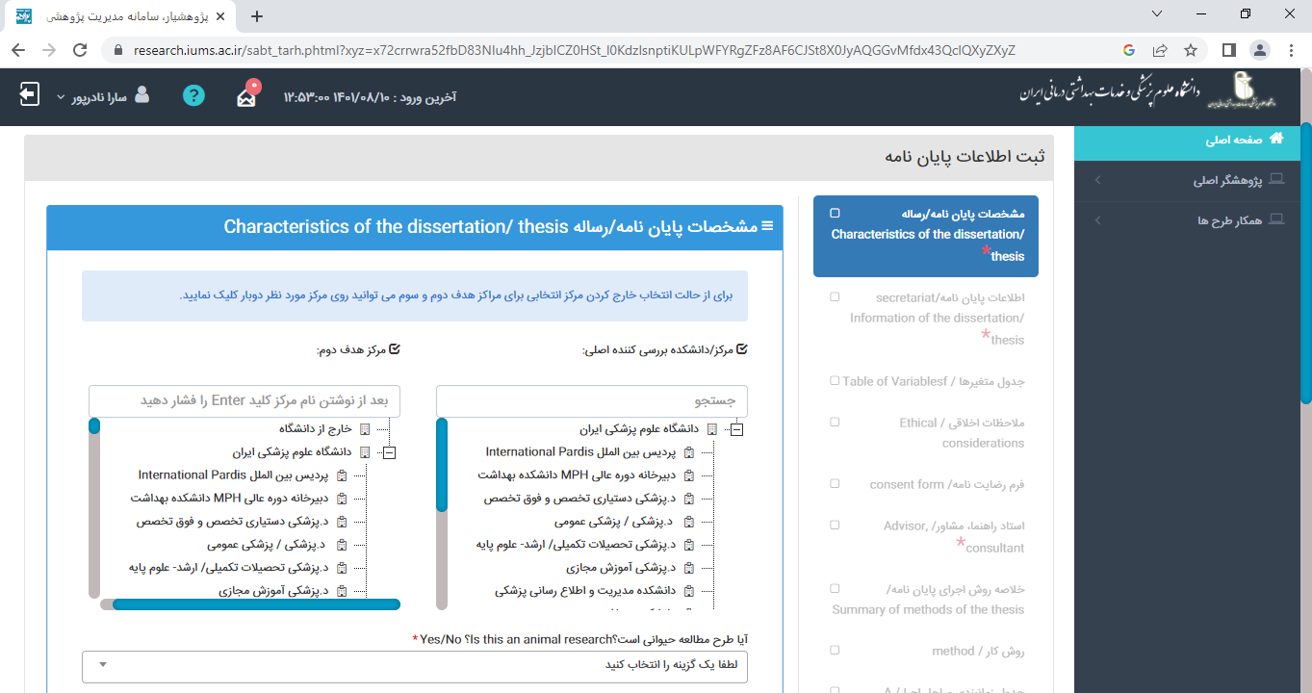

Finally, after completing all sections related to the characteristics of the dissertation/thesis, select the "Submit" option to save the information and access other sections. After selecting the "Submit" option, a message titled "Operation Successful" will appear, and by clicking on the "Confirm" button, you can access and complete other sections.

Note: It is important to complete all sections (both starred and non-starred) as they are necessary for review and subsequent stages. These pieces of information represent your thesis proposal in electronic format.

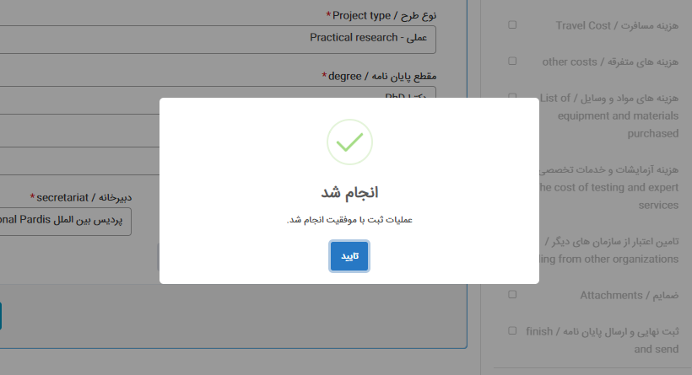

Note: Each completed section of the dissertation will have a checkmark symbol (☑) next to it, indicating completion of the corresponding section.

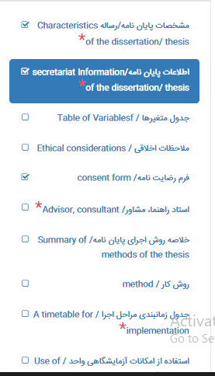

Once the first part, "Characteristics of the Dissertation/Thesis," is completed, all sections for entering dissertation information will be saved and accessible. You can continue completing different sections until the final stage, "Finish and Send," is carried out. If not completed, you can access and edit the sections at other times by revisiting the system.

**Secretariat Information of the Dissertation/Thesis:**

* In the next step, the sections related to the "Secretariat Information of the Dissertation/Thesis" (type of thesis in terms of clinical trial, keyword entry in Persian and English, introduction , statement of the need, research questions and hypotheses, specific objectives of the thesis, study innovation, definition of terms, reference list) should be completed. At the end of the page, by clicking on the "Save" option, the entered information will be saved, and you can proceed to the next step, which is entering information in the variable table.

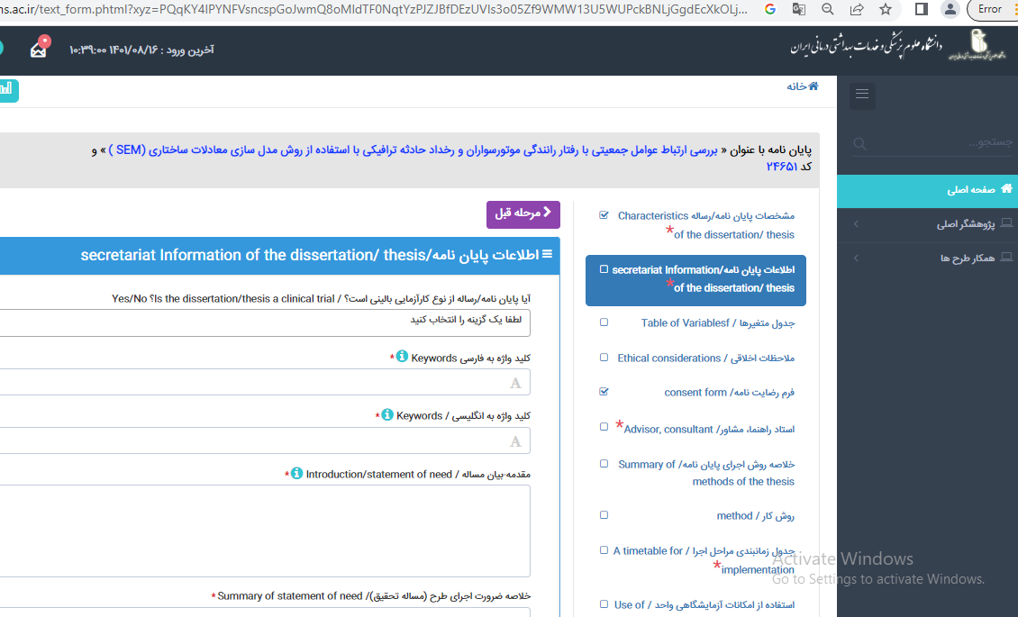

**Table of variables**

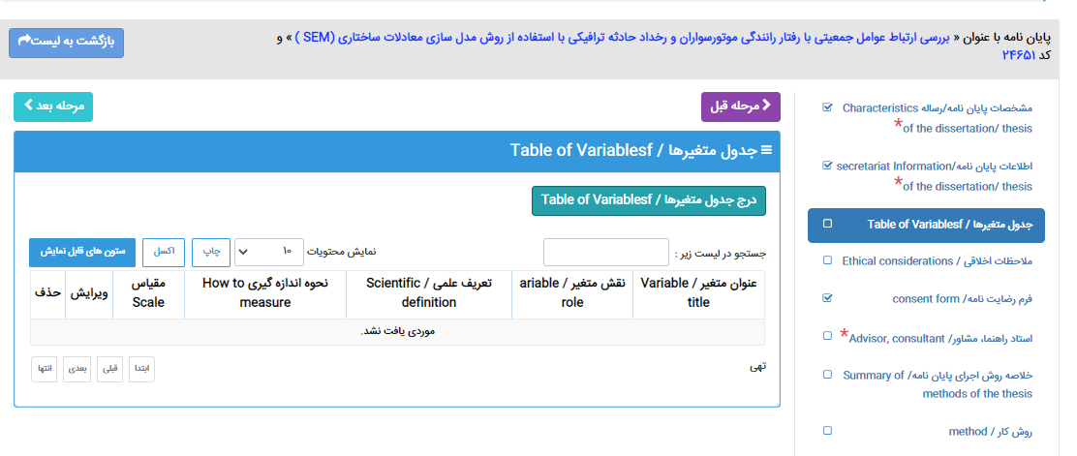

In this section, click on the " Table of Variables" section and enter the specifications of each variable (Variable title, Variable role, Variable type, Scientific definition of the variable, How to measurement, and scale). Click the "Save" option so that the desired variable with the entered characteristics appears on the main page

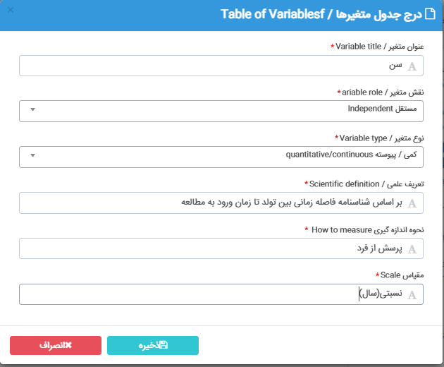

It should be noted that all these steps are repeated for all variables present in the proposal until all variables are displayed in the table of variables. In this section, it is still possible to edit and delete variables.

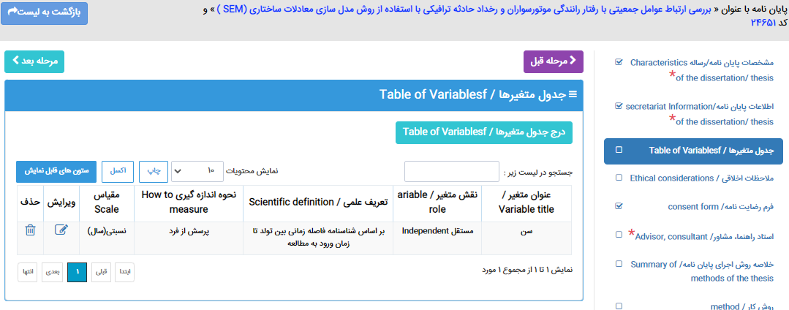

**Ethical Considerations:**

* The questions in this section are completed based on the information provided in the approved proposal.

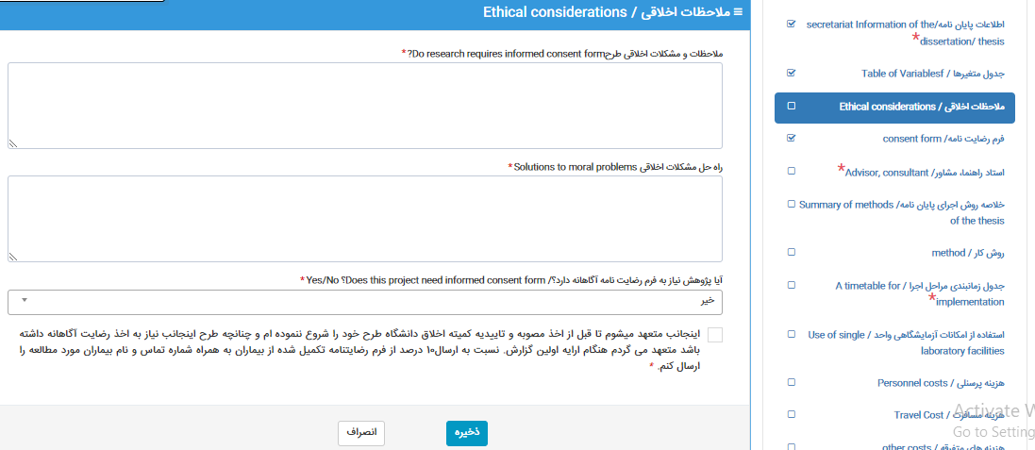

* **Consent Form:**

If you have indicated the need for a consent form in the previous step (ethical considerations), all requested information must be entered in this section. The consent form should be completed in simple language and by the patient, and at the end, enter the supervisor's information.

Link to the guide for completing the consent form:

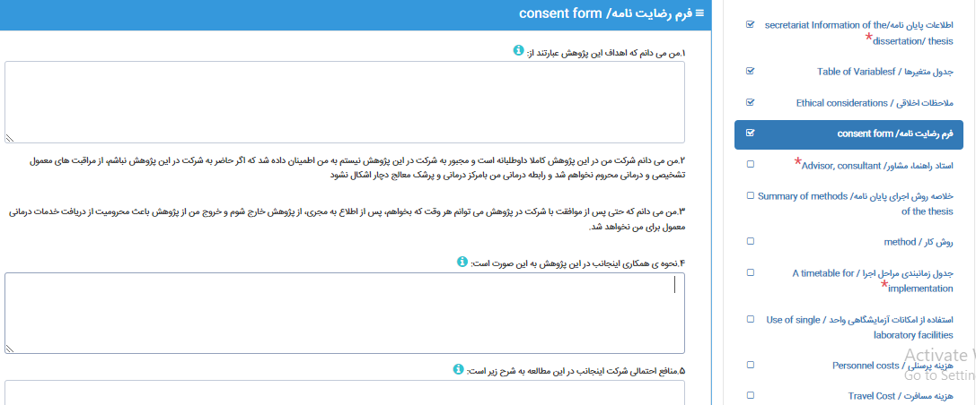https://rec.iums.ac.ir/uploads/502/2022/Sep/05/%D9%86%D8%AD%D9%88%D9%87_%D8%AA%DA%A9%D9%85%DB%8C%D9%84_%D9%81%D8%B1%D9%85_%D8%B1%D8%B6%D8%A7%DB%8C%D8%AA_%D8%A2%DA%AF%D8%A7%D9%87%D8%A7%D9%86%D9%87%20(2).docx

* **Advisor, Consultant:**
* In this step, enter the name of the relevant advisor/consultant in the "Search in the following list:" section.

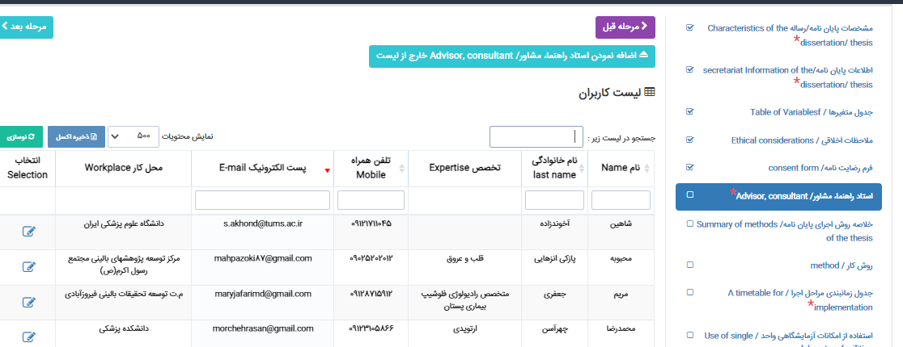

After searching, the name of the advisor will be displayed at the bottom of the page. By clicking on the "Select" option at the end of the displayed table, you can determine the role of the advisor in the project or thesis, whether it is a supervisor or a consultant, and their order.

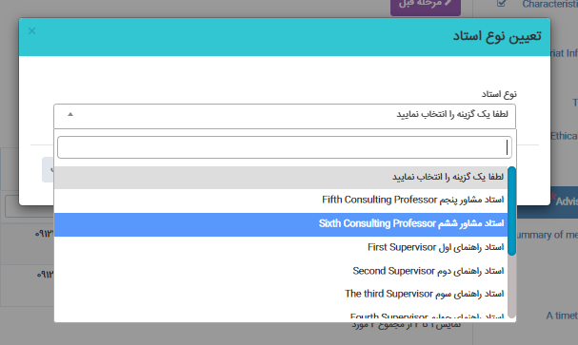

**Summary of the Methods of the Thesis:**

* Select the "Summary of the methods of the thesis" option and enter the relevant information. Finally, click on the "Save" option.

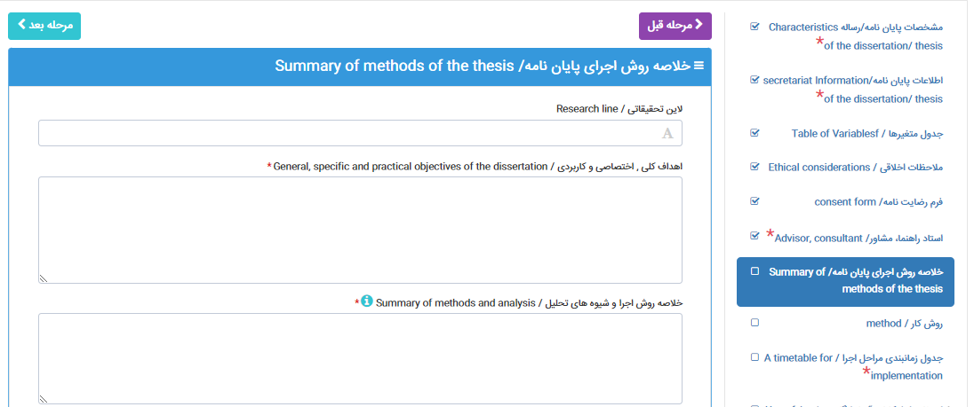

**Method**:

In the method section, enter information related to the research methodology such as the description of the study type, data gathering, calculation method for sample size, inclusion and exclusion criteria, specifications of data collection tools, data collection and analysis method. Click the "Save" option to save the entered information.

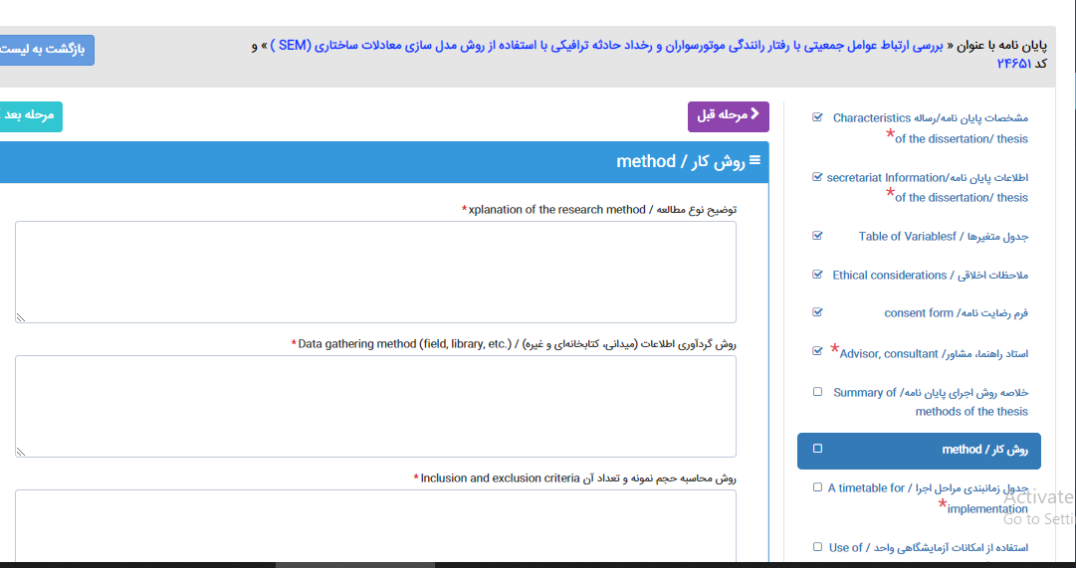

**A Timetable for Implementation:**

In this section, enter the information related to the project's implementation timeline.

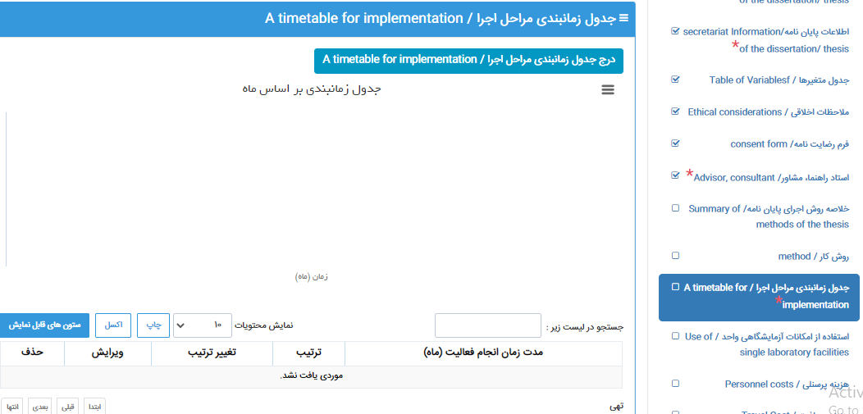

To do this, select the "Time table for implementation" option. A table for entering information for each activity (title, start month, end month) will appear, and you can complete the requested information.

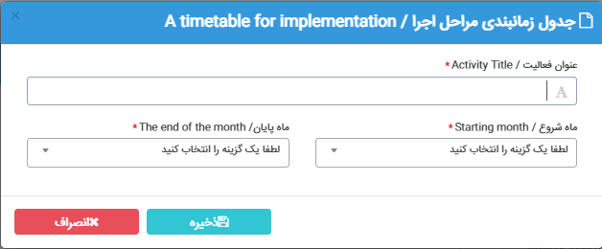

After completing the information for each activity and selecting the "Save" option, the selected activity will be displayed on the implementation timetable page. The timing of activities will be shown both graphically and in the lower part of the page, indicating the duration of each activity, which can be edited if needed.

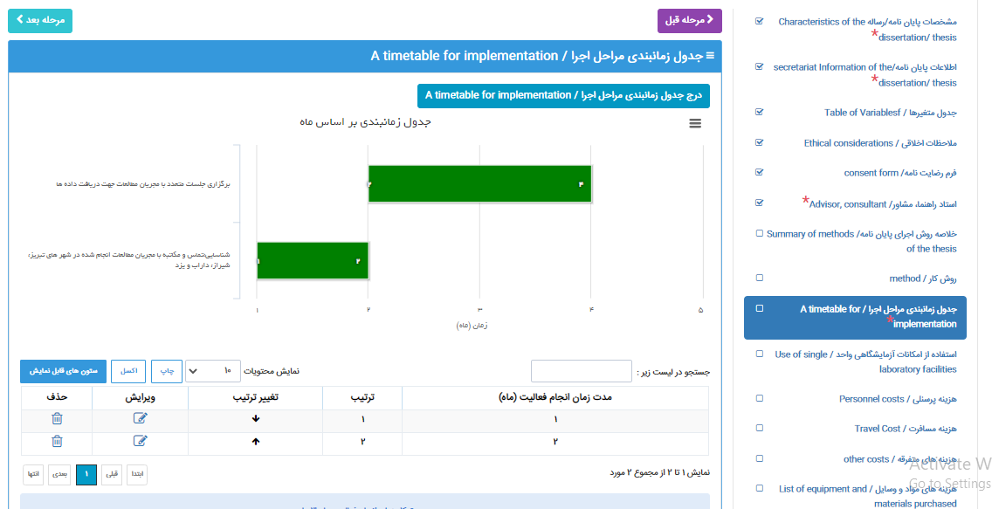

**Use of Single Laboratory Facilities**: (**If the thesis is a research project, complete this section**.)

If the thesis or relevant project requires the use of laboratory facilities, list the requested materials and equipment in this section. To register a request for materials or laboratory facilities, select the "Register a new case of using laboratory facilities" option. Complete the relevant sections (type of laboratory, required equipment, materials and supplies, required quantity) as shown in the example, and then select the "Save" option. After entering the information for each request, the list of requested materials/equipment will be displayed in a table on the main page, which can be edited or deleted until the final submission of the thesis. In this section, in addition to registering the list of required materials/equipment, three questions should be answered at the bottom of the table.

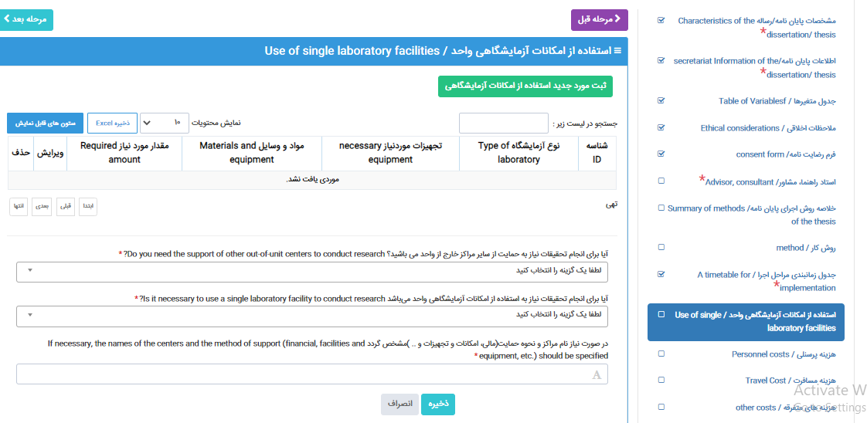

**Entering Project/Thesis Expenses**: (If the thesis is a research project, complete this section.)

* 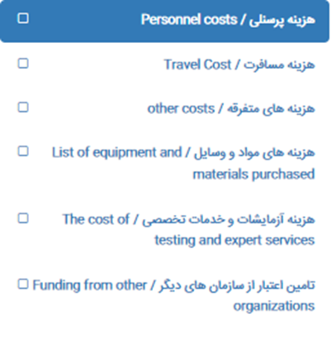The expense information includes personnel costs, travel expenses, miscellaneous expenses, material and equipment costs, testing costs, and specialized services. By selecting each section and clicking on it, the corresponding page will open for completion and registration of the request.

**Attachments**: Uploading 3 mandatory items:

1. Minutes of the Proposal Defense Meeting
2. Completed Evaluation Form
3. First page of the advisor's latest published article in the attachments section, all tables, charts, and figures used in the proposal should be entered separately.

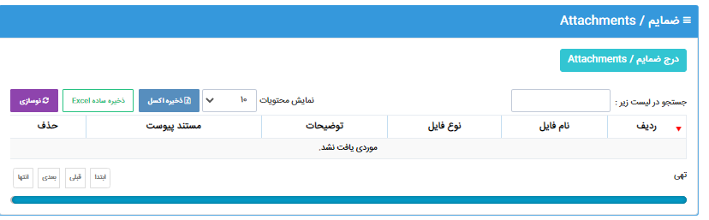

To do this, select the " Attachments" option as shown below, and the corresponding page will open. You can use the "Select" option to find and upload the desired file. Note that the name of the file should be written in the Attachment Type field, and if there is any specific description about the file, you can write it in the Description field. Finally, click on the "Upload" button to upload the file. Please note that after uploading the file, the options to change and delete the file will still be active.

**Note**: When sending the desired file, please pay attention to the following:

* The maximum allowed file size for upload is 50 megabytes.
* The allowed file extensions for document submission are doc, docx, pdf, zip, rar, jpg, png, gif, mp4, mp3, xlsx, xls.
* The allowed file extensions for image submission are png, jpg, jpeg, gif.
* Please make sure to upload the required file in the Attachment Type field if it is mandatory, to avoid errors during submission.

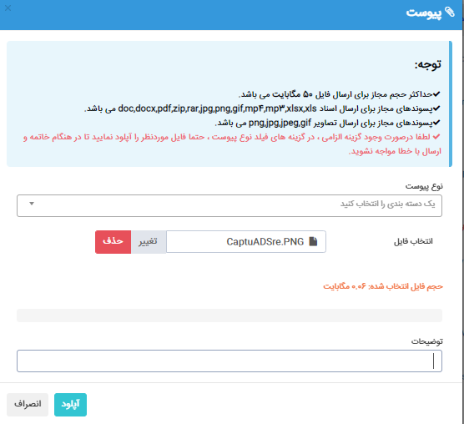

**Final Registration and Submission of the Thesis (Finish and send):**

In the final registration and submission section of the thesis, by clicking on the "Preview" button, you can view the entered information for further review and ensure the accuracy of the steps. If necessary, you can make necessary changes before final registration.

**Note**: By clicking on the Send and Exit button, you will exit the editing mode, and after that, you will no longer be able to make edits. Until you click the Send and Exit button, the submission will not be completed, and the project/thesis will remain in your workspace

